**How to disable push notifications in chrome?**

Sometimes, when you are automating, some sites will show you a notification pop up on the top asking you permission

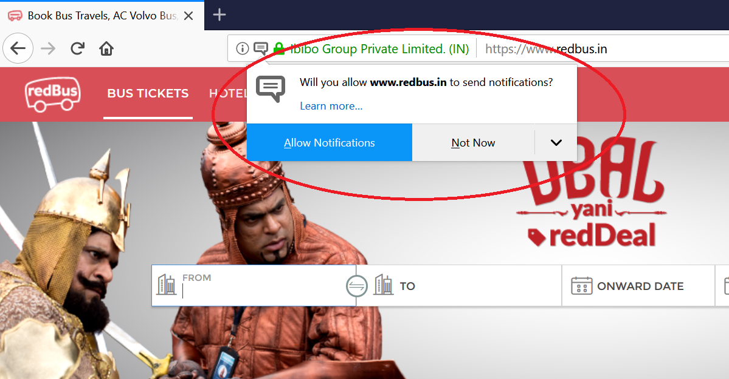

These notification popups will create problems with the automation scripts. So we need to handle them by not showing them during running our automation scripts.

For chrome, we will have to use chromeoptions() to disable these kind of notifications.

chromeoptions is a class that you can use to customize and configure a chrome session.

**package** Selenium;

**import** org.openqa.selenium.By;

**import** org.openqa.selenium.WebDriver;

**import** org.openqa.selenium.chrome.ChromeDriver;

**import** org.openqa.selenium.chrome.ChromeOptions;

**public** **class** disableChromeNotifications {

**public** **static** **void** main(String[] args) {

//Disabling Chrome push notifications

ChromeOptions ops = **new** ChromeOptions();

ops.addArguments("--disable-notifications");

System.*setProperty*("webdriver.chrome.driver", "C:\\BrowserDrivers\\chromedriver.exe");

WebDriver driver = **new** ChromeDriver(ops);

driver.manage().window().maximize();

driver.manage().deleteAllCookies();

driver.get("https://www.redbus.in/");

driver.findElement(By.*xpath*("//input[@id='src']")).sendKeys("Hydera");

}

}